Thanyl 6

Product Description
Thanyl 6 is a broad-spectrum fluid with enhanced action against bactericides, fungicides, yeasticides and virucides. It has the lowest formaldehyde index on the market, considerably reducing the exposure for funeral professionals. Its formaldehyde-based formula, combined with its active agents, makes it particularly effective in cases of gaseous emphysema and against gas tissue.
Standard adult body dose: To be used non-diluted between 250ml and 500ml.

Technical Data
 | Thanyl 6
Height | 24 cm
Capacity | 1L
Active ingredients | Formaldehyde and quaternary ammonium
Colour | Transparent
Storage | Keep away from direct sunlight and high temperatures
Safety precautions | Wearing Personal Protective Equipment (see safety data sheet)

CE marking / Norms / ISO
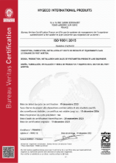
Hygeco International products hold the ISO 9001: 2015 certification registered under No. FR084950-1 valid until December 18, 2026.
We certify that our products are conditioned, packaged and labelled in compliance with standards in accordance with our internal charter and considering the specific requirements of our customers.
.

