Arthyl 26

Product Description
Arthyl 26 is a multipurpose arterial fluid containing glycerol, allowing good tissue penetration. Its stable formulation makes it more resistant to changes in temperature and environment.

- Contains glycerol
- High-performance at all temperatures
- Ideal for necrotic, autopsied, emaciated and decomposing bodies
Standard adult body dose: 20ml to 40ml per litre of water.

Technical Data
 | Arthyl 26
Height | 24 cm
Capacity | 1L
Active ingredients | Formaldehyde, methanol et glycerol
Colour | Red
Storage | Keep away from direct sunlight and high temperatures
Safety precautions | Wearing Personal Protective Equipment (see safety data sheet)

CE marking / Norms / ISO
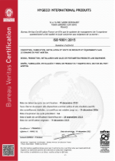
Hygeco International products hold the ISO 9001: 2015 certification registered under No. FR084950-1 valid until December 18, 2026.
We certify that our products are conditioned, packaged and labelled in compliance with standards in accordance with our internal charter and considering the specific requirements of our customers.

